The Game starts with a option panel which will slide up as you click on it and slide down on clicking again which give it a toggle kind of view.

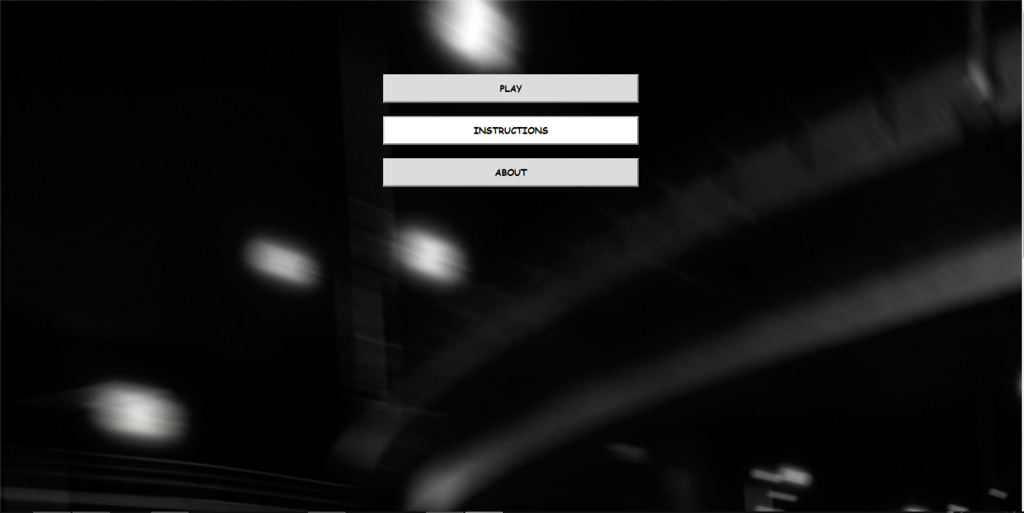

The three options are PLAY, INSTRUCTIONS,ABOUT   
PLAY: This section is further divided into three parts which are indeed three levels of the game. At each level the difficultty of game increase.   
INSTRUCTIONS: This section elaborates about the game rules and game keys.  
About: This tells about the version currently.

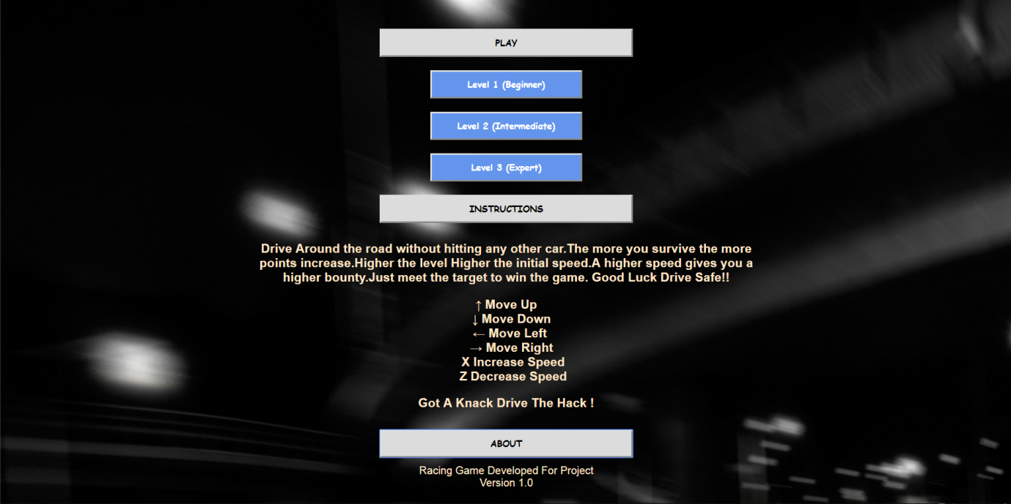

On clicking any of the level the screen will roll down to game screen where game will start as soon as you come to the game screen.  
The game consists of three labels :Target,Score,Speed:  
Target:The Score you have to achieve so as to win.  
Score:Your currently earned points.  
Speed:Your current speed of car.

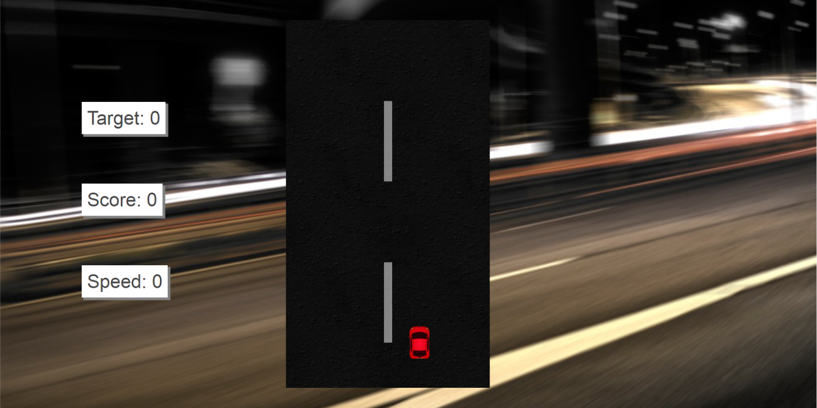

Unfortunately, If you smashes any car your game will be over and a option to play again or abort will come in form of Yes and No option.

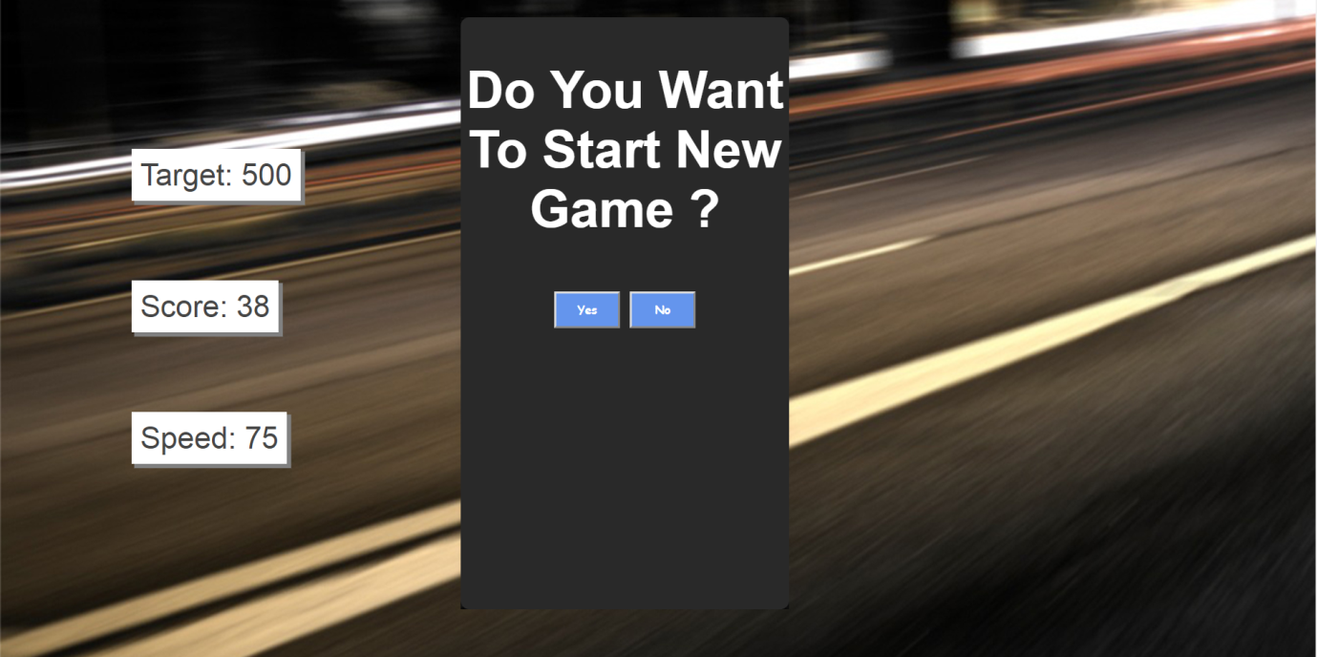

Fortunately, If you win you will be asked if you want to start a new game at same level or not.

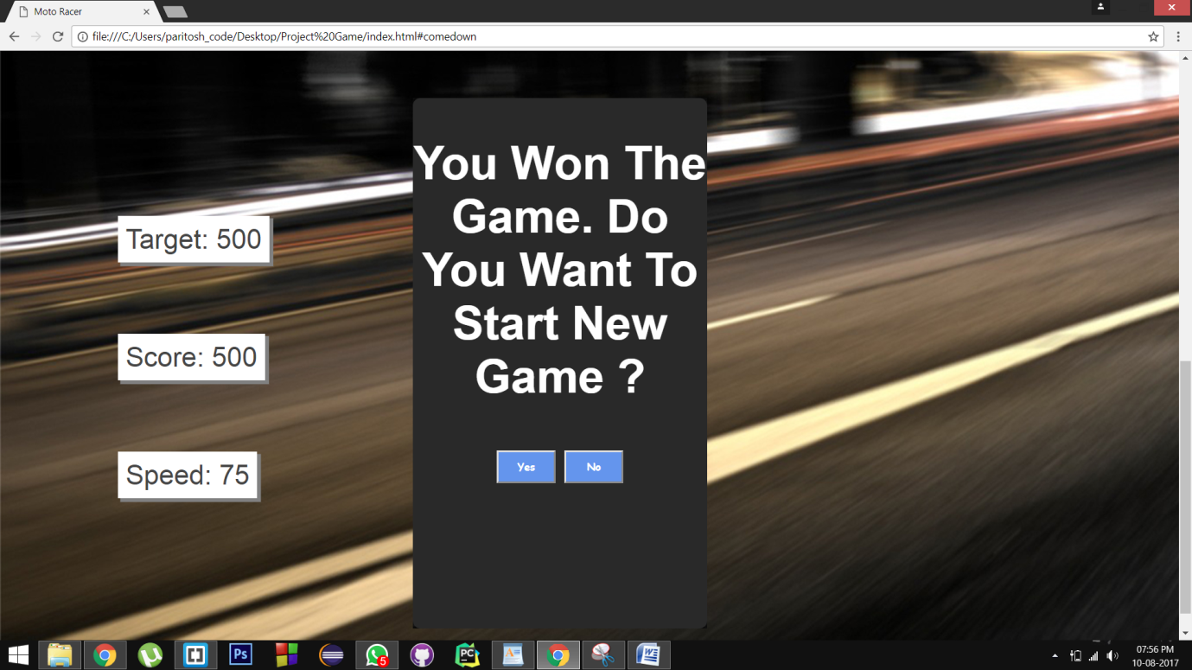

FINAL LOOK:

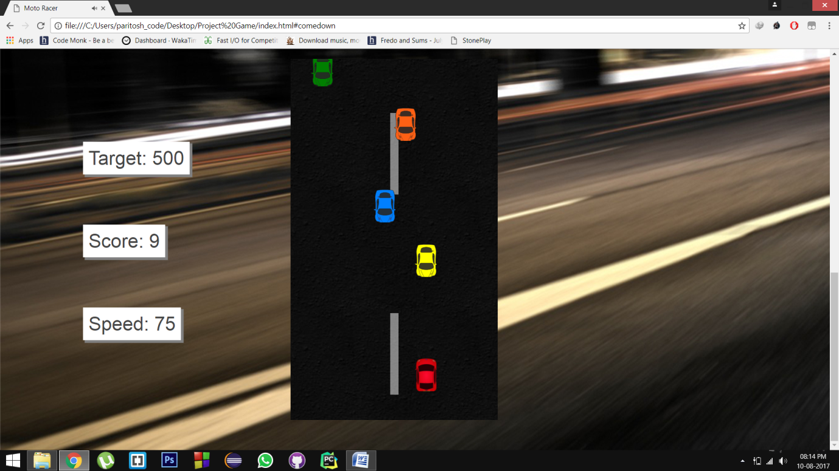

GOT A KNACK SHOW THE HACK !  
GOOD LUCK PLAYING :D